Case Study

Mega Events : How 2012 led to 2017
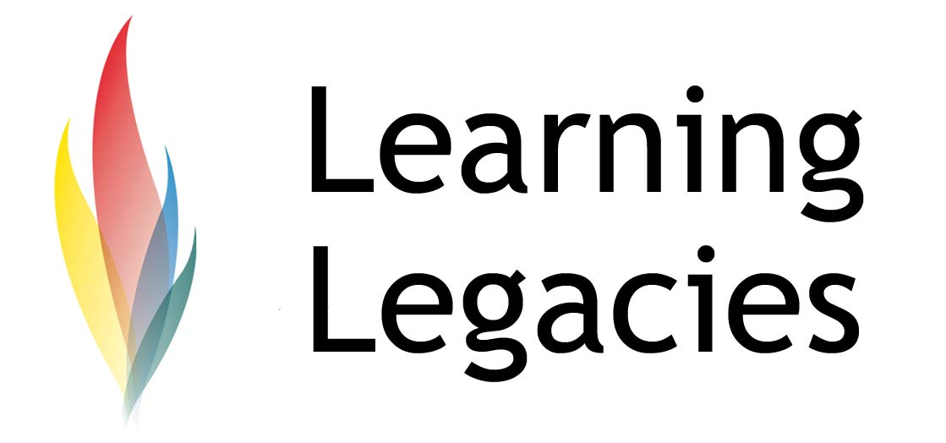

Mega Events – How 2012 Led to 2017

A vital weapon in the arsenal of mega-event bidding – especially for large scale sporting events – is a successful track record of hosting events of the same kind, on budget, on time, and with great press coverage and legacy goals achieved. No doubt winning the rights to host the 2012 Olympic & Paralympic Games helped in large part to pave the way for GB’s successful bid to host the 2017 World Championships in London.

From 2012 – 2017 – to Doha?

The bid – and subsequent win – achieved by London was made all the more interesting in the context that one of the other rival contenders, Doha, had also bid for the rights to stage the 2017 event, a move also seen to potentially pave the way for Doha’s bid to also host the 2010 Olympic and Paralympic Games. Doha has historically presented a large scale financial commitment to bids (one of the reasons why Doha was able to run such a successful- and victorious - campaign for the 2022 Football World Cup. Doha remains a potential favourite for the 2020 Olympic Games, also enabled by the weakened financial strength of rivals Madrid and Rome, given the deepening severity of the global financial crisis that continues to severely weaken the Eurozone. Tokyo and Istanbul remain forerunner, although Tokyo is currently facing the impact of natural disaster. Nevertheless, winning the 2017 bid would have helped Doha - a win that was claimed by London instead.

The IOC have voiced concerns over the Doha Olympic bid – namely the related issues of climate and scheduling. These concerns have also been raised with respect to the Football World Cup (concerns over a host cities ability are often raised before events, as in the case of the IOC highlighting concerns about the transport infrastructure associated with the London bid). However the battle is by no means over – it is thought that a majority of IOC officials who sit on the IAAF council actually bid in favour of Doha, not London.

Nevertheless, one can observe how winning the rights to stage one competition can serve as an indicator of success – or lack of it – in future potential bids for other large scale sports competitions.

The Financial Cost of 2017

Whilst the deepening Eurozone crisis threatens to engulf the continent, GB is also suffering. There have been concerns about the use of public funds to bid for sports competitions when the country is entering a recession and badly needs funding for public services such as hospitals, schools and policing.

However, the Mayor of London, Boris Johnson, has told London taxpayers that they will not face the brunt of the cost of financing the Games. In particular, he has referred to an extra £5 million investment that London assured the 2017 World Athletics Championships in order to secure the win. This £5 million figure takes the form of prize money for athletes. Rivals Doha also offered the sum (in fact, Doha’s overall investment exceeded that of London’s). This brings the total cost to London of approximately £30 million.
Further Information
- Government statement on their backing for London to host the 2012 World Athletics Championships
http://www.culture.gov.uk/news/news_stories/8402.aspx
- UK Sport Statement: 2017 Bid Confirmed
http://www.uksport.gov.uk/news/2017-World-Athletics-Championships-bid-confirmed-180811
- IAAF Website
http://www.iaaf.org/

Discussion
- Given the deepening crisis of the Eurozone – and its effect on GB – do you agree that it is the right time to bid for large sporting events such as the World Athletics Championships in 2017?
- The failure of the Doha 2017 bid has served as an indicator to the Doha bid team and international sporting community of the potential success of Doha’s 2020 Olympic bid. Do you think that such perceptions are correct

Case Study

WOMENS PARTICIPATION IN THE OLYMPIC GAMES
- or that the success of the Doha 2020 bid remains particularly strong and unaffected?

- What does this case study tell us about the need to demonstrate a successful track record in the bidding for future events?

Case Study

Mega Events : How 2012 led to 2017

Mega Events How 2012 led to 2017 PARTICIPATION IN THE OLYMPIC GAMES

This resource was produced as part of the 2012 Learning Legacies Project managed by the HEA

Case Study

Mega Events : How 2012 led to 2017

WOMENS PARTICIPATION IN THE OLYMPIC GAMES
Hospitality, Leisure, Sport and Tourism Subject Centre at Oxford Brookes University and was released as an Open Educational Resource. The project was funded by HEFCE and part of the JISC/HE Academy UKOER programme. Except where otherwise noted above and below, this work is released under a Creative Commons Attribution only licence.

Exceptions to the Licence
The name of Oxford Brookes University and the Oxford Brookes University logo are the name and registered marks of Oxford Brookes University. To the fullest extent permitted by law Oxford Brookes University reserves all its rights in its name and marks, which may not be used except with its written permission. The JISC logo is licensed under the terms of the Creative Commons Attribution-Non-Commercial-No Derivative Works 2.0 UK: England & Wales Licence. All reproductions must comply with the terms of that licence.

The Higher Education Academy logo is owned by the Higher Education Academy Limited and may be freely distributed and copied for educational purposes only, provided that appropriate acknowledgement is given to the Higher Education Academy as the copyright holder and original publisher.

Reusing this work
To refer to or reuse parts of this work please include the copyright notice above including the serial number. The only exception is if you intend to only reuse a part of the work with its own specific copyright notice, in which case cite that.

If you create a new piece of work based on the original (at least in part), it will help other users to find your work if you modify and reuse this serial number. When you reuse this work, edit the serial number by choosing 3 letters to start (your initials or institutional code are good examples), change the date section (between the colons) to your creation date in ddmmyy format and retain the last 5 digits from the original serial number. Make the new serial number your copyright declaration or add it to an existing one, e.g. ‘abc:101011:011cs’.

If you create a new piece of work or do not wish to link a new work with any existing materials contained within, a new code should be created. Choose your own 3-letter code, add the creation date and search as below on Google with a plus sign at the start, e.g. ‘+tom:030504’. If nothing comes back citing this code then add a new 5-letter code of your choice to the end, e.g.; ‘:01lex’, and do a final search for the whole code. If the search returns a positive result, make up a new 5-letter code and try again. Add the new code your copyright declaration or add it to an existing one.

